SECTION IV – BIOLOGICAL STATISTICS

1. Hypothesis testing:

A method used to make statistical inference of collected and examined data.

Types: Analysis of Variance(ANOVA), T test, Chi-square test, Normality.

Used in medical research, business applications, clinical decision making.

1. Correlation:

Measuring the relationship between two variables. It is classified into two types, namely

Positive correlation (both the variables or values increase) and

Negative correlation (one value increases and the other decreases).

1. Methods:

Karl Pearson’s correlation coefficient

P value

Spearman’s coefficient of correlation

1. P value:

It is the probability of statistical data and it is the mean difference between two statistically compared variables or values.

P value is compared with the pre-determined (0.05) and if

P value < 0.05

Then, the null hypothesis test is neglected.

1. I have calculated manually, so I have drawn the graph in a paper and attached as an image with this document.

a) Sample mean

= 16.608

Sample variance

= 355.307

Sample standard deviation(SD)

= 18.849

Empirical distribution function of the data

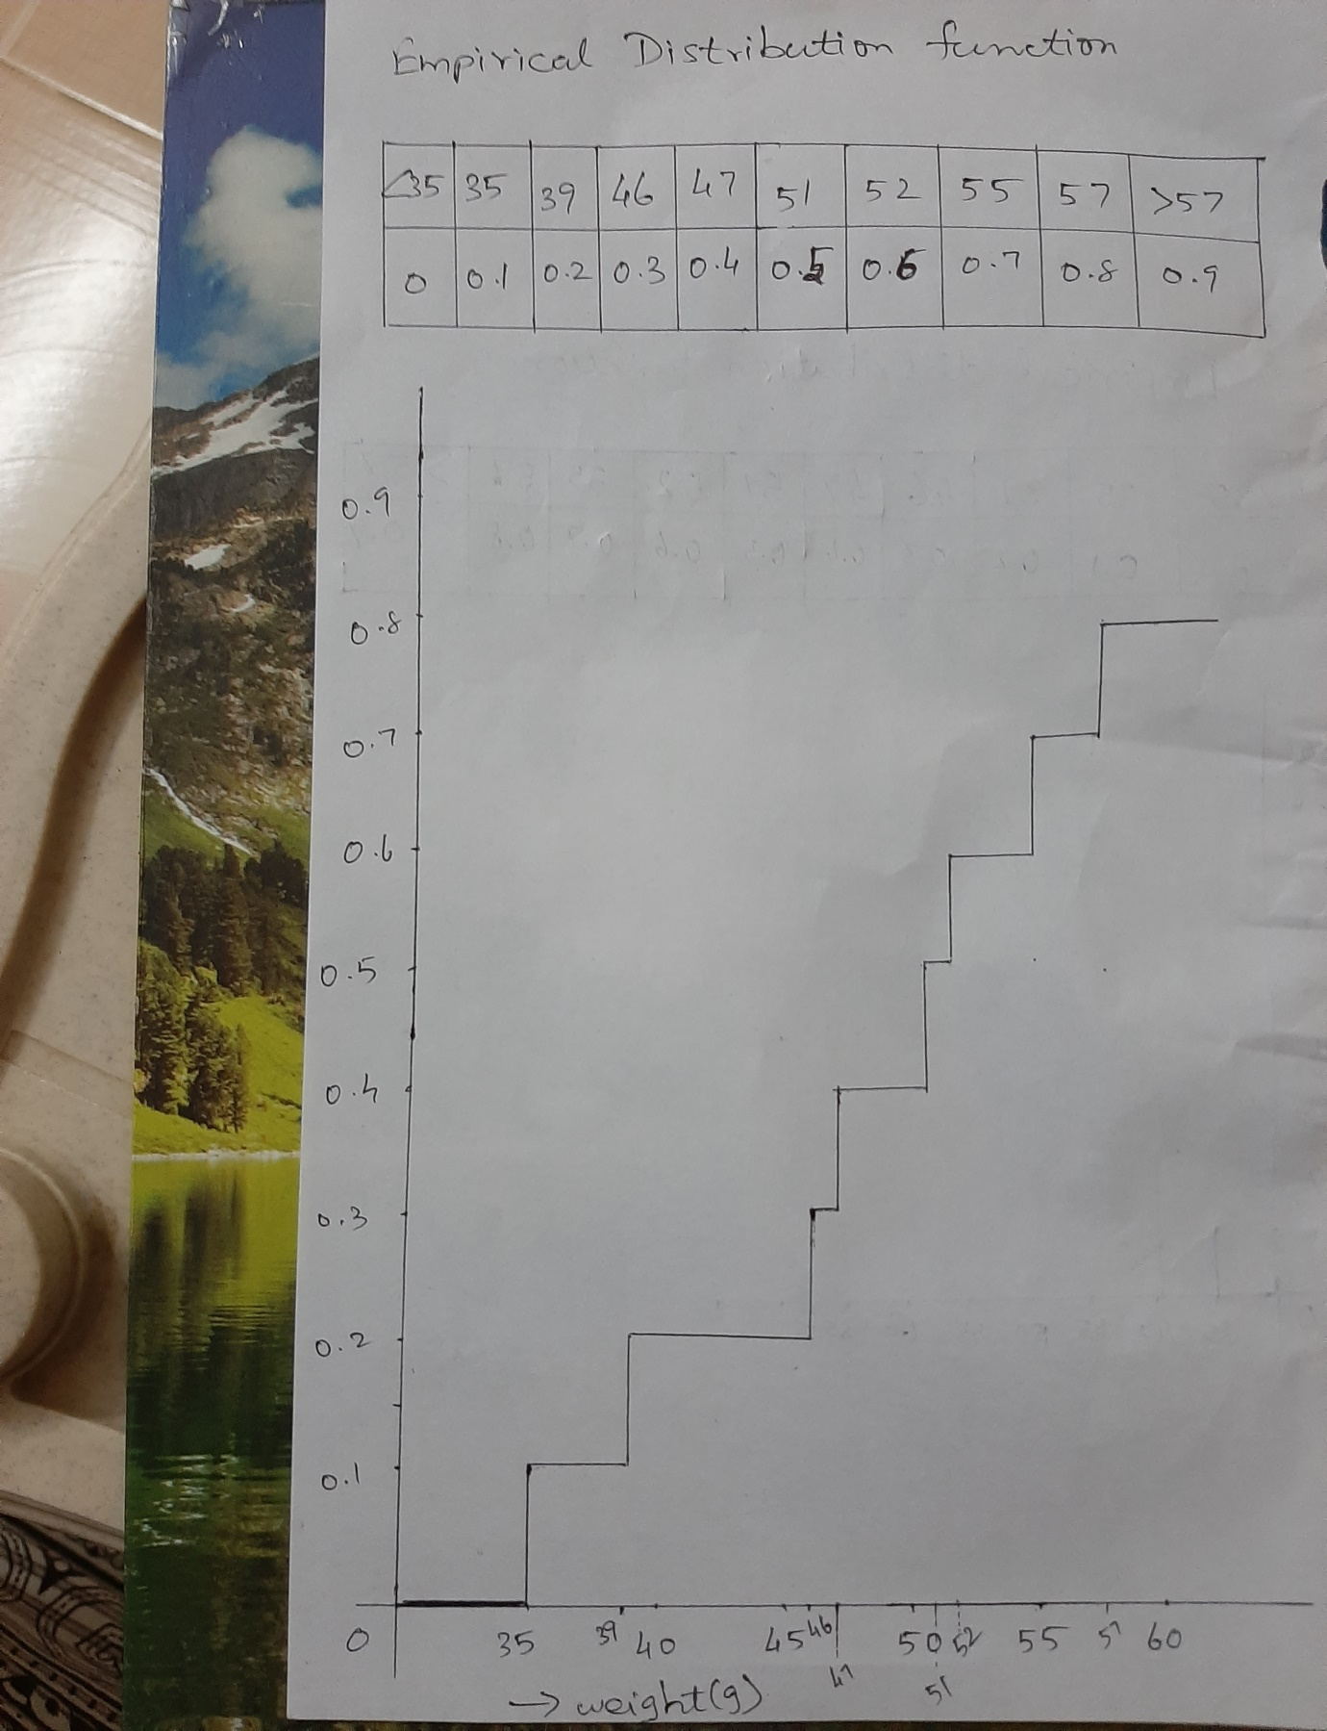

1. median = (47+51)/2=49

25% quantiles = (39+46)/2

= 42.5

50% quantiles = 49(median)

75% quantiles = (55+52)/2

= 53.5

1. i) mean = 173.1

variance = 610.89

ii) 95% confidence interval for mean height

= (157.47,188.73)